GIT MERGE CONFLICTS

1)Create new git repository (Eg:AIEmerge)

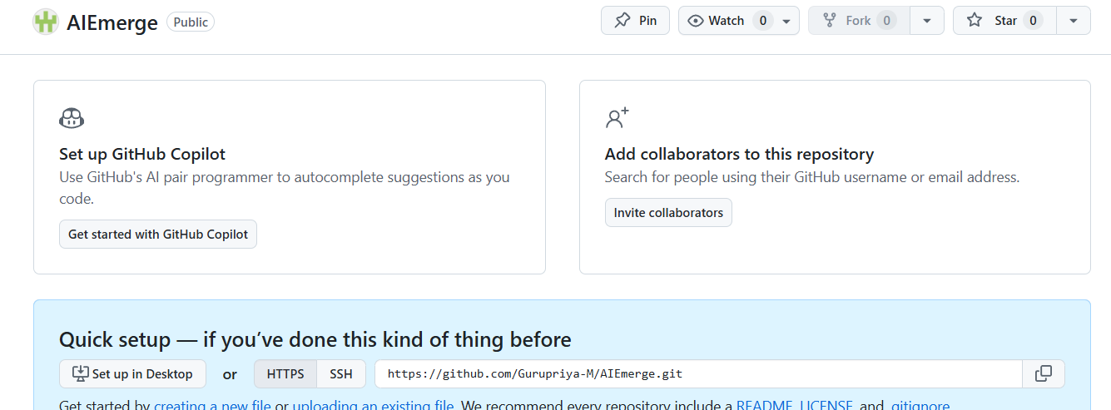

2)Goto git bash and create new git folder(Eg:merge)

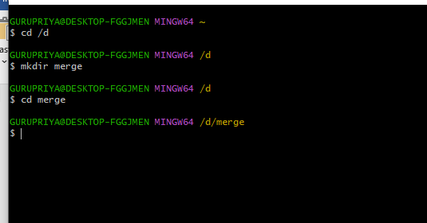

3)Initialize git repository



4)Open visual studio code ->select your git folder(i.e merge)->create new html file(i.e sample.html)

Type the code

(I just added <p>amrita Bengaluru</p>)

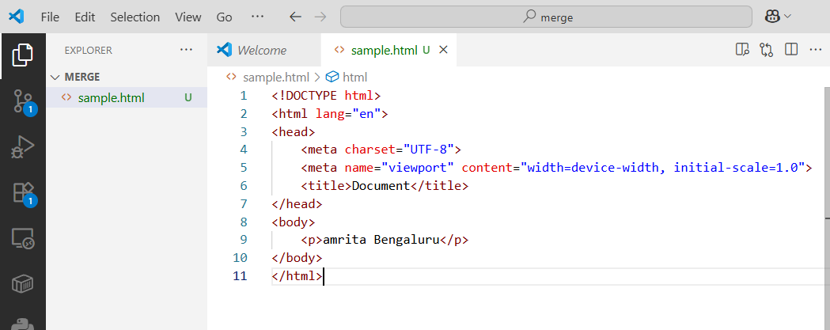

5. Goto git bash and perform “add” & “commit” commands

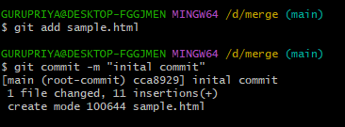

6.Add URL to gitbash



7. Use “PUSH” command to push to git hub repository

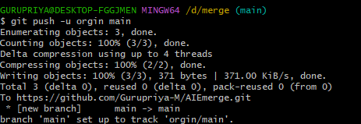

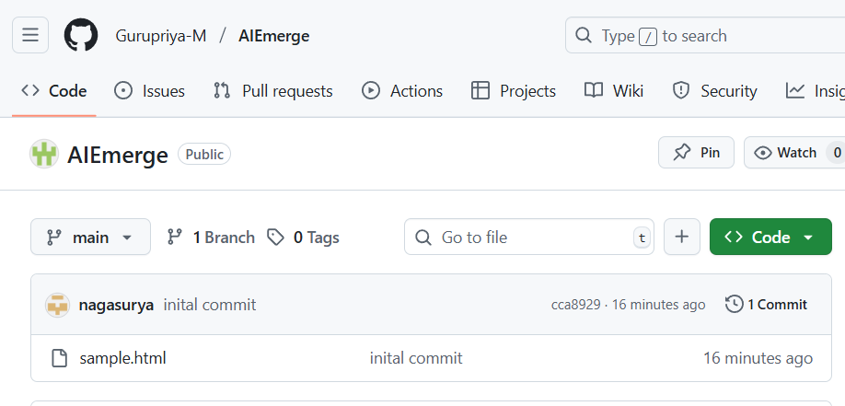

Now new file has been created and pushed to github repository.

8.Create new branch using following command



9. New branch called test is created .To checkout branches in your system use following command



10.Push the new branch to git hub repository

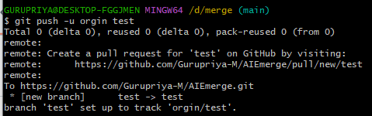

11.Now my new branch is empty, no files are present. To copy files from main branch use following command. To do this, first you need to goto destination branch(test)

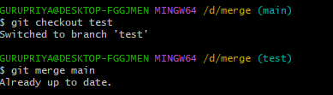

12.Now both main and test branches has same file(smple.html)

13.Test branch changes something in sample.html and performs “add”,”commit” alone

First goto test branch and open visual studio code and do the changes.

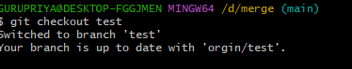

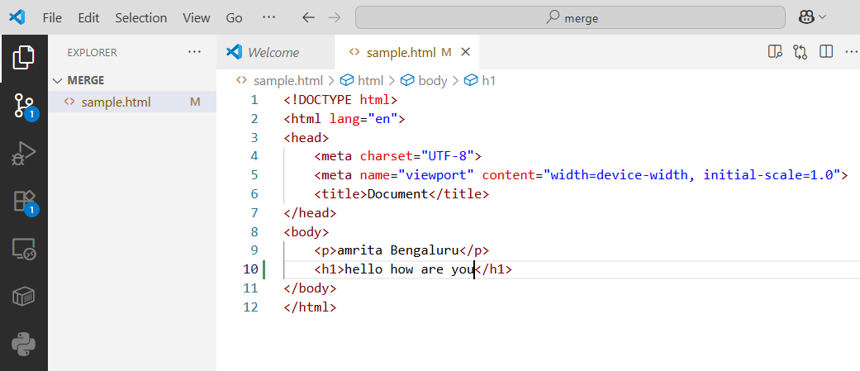

14.Goto git bash perform following commands(These changes are done only in test branch and it is not pushed to github repository)

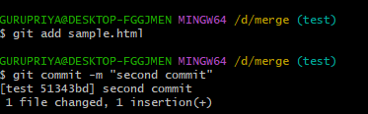

15.Meanwhile main branch wants to change something in sample .html file

First goto main branch using command

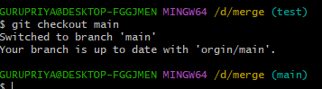

16.Now change the code

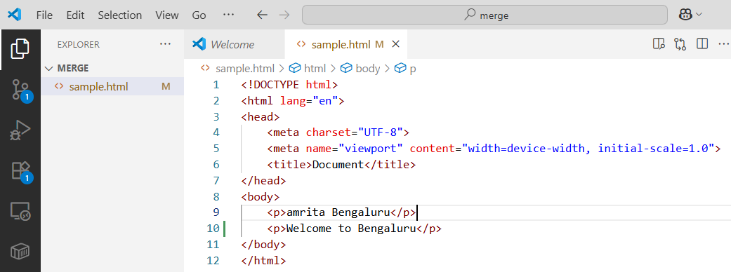

17. Perform add,commit and push command

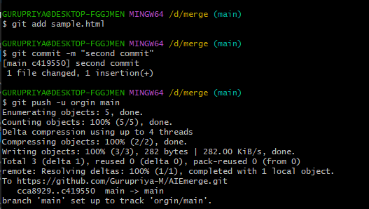

18.Now main branch has updated file .Unaware of this test branch tries to merge with main and merge conflict occurs.

First goto destination branch and perform merge command

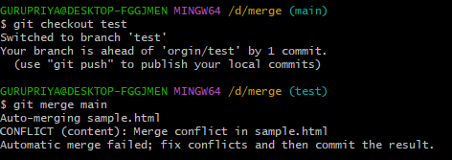

19.You should get merge conflict error.Goto visual studio code and observe this change

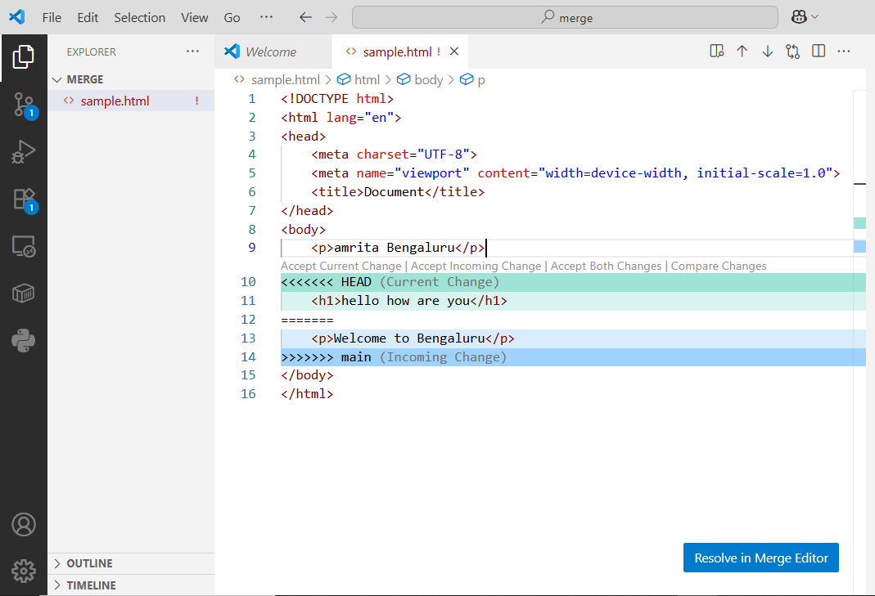

20.Now click accept both changes->Resolve in merge editor->complete merge->continue

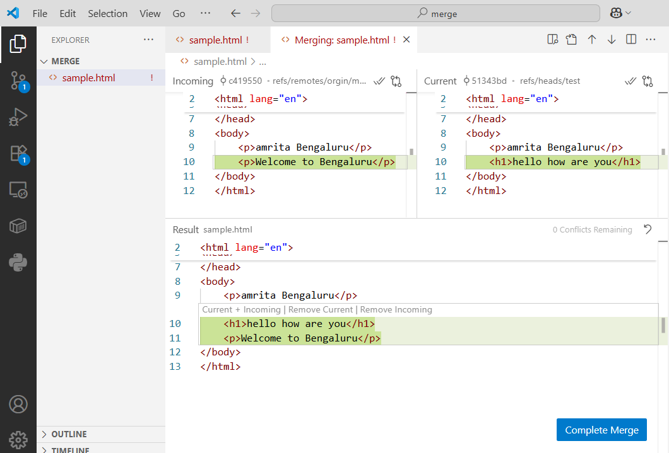

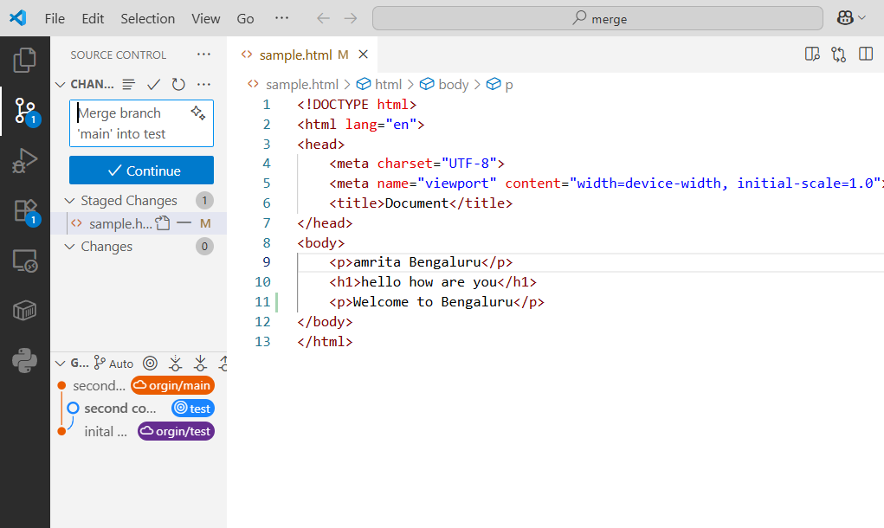

21)git push and then check updated file in github repository

